Exercise 1.9: Write a program that uses a while to sum the numbers from 50 to 100.

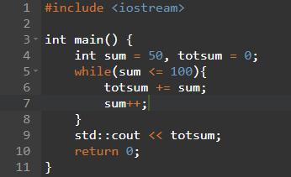

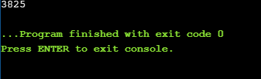

Exercise 1.10: In addition to the ++ operator that adds 1 to its operand, there is a decrement operator (--) that subtracts 1. Use the decrement operator to write a while that prints the numbers from ten down to zero.

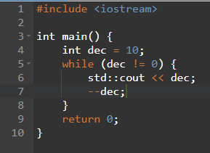

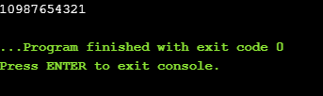

Exercise 1.11: Write a program that prompts the user for two integers. Print each number in the range specified by those two integers.

